Tansley in Bloom 2016
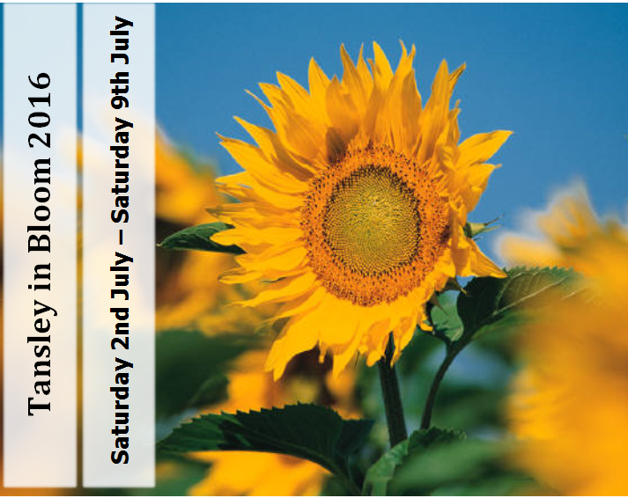
Garden and Home Produce Competition
Schedule and Entry Form
Saturday 9th July 2016
Tansley Village Hall, Church Street, Tansley.
Entries: | By Sunday 3rd July
Staging: | 9.00a.m – 11.30a.m. on the day of the show
Judging: | 12.00p.m.
Show Opens: | 2.00p.m.
Prize Giving and Raffle Drawn: | 3.30p.m.

Kindly Sponsored By:-

Please read all introductory
notes and class descriptions
carefully.

Entries must comply with descriptions to make it fair for all, as disqualification can be upsetting.

Please do not be daunted by the ‘rules’;
entering the show is fun and we want as many entries as possible but we want it to be
equal for all.

If you are in any doubt, please ask!

The Competition is open to all residents within the settlement of Tansley. Certificates will be awarded to winners in the Adult classes.

Flower Classes

- Flowering Pot Plant (any type).
- Cut Flowers in a vase - annuals, a mixed collection not more than 5 kinds.
- 3 Roses in a vase.
- 1 stem, Roses in a vase. To be judged on fragrance by the public.
- 6 spikes of Sweet peas in a vase - one or more variety.
Judges Hints and Tips:-
- All exhibits in the Flower Classes MUST have been grown by the exhibitor.
- All exhibitors must provide their own equipment as no vases will be available for use in the Village Hall when staging.
- No dried or silk flowers are allowed.
- Accessories including bows and additional foliage are not allowed.

Flower Arrangements Classes

- A floral arrangement (Max. 18” x 18”).
- An arrangement of artificial or dried flowers, or seed heads (Max 18” x 18”).
Judges Hints and Tips:-
- All exhibits must be the unaided work of the exhibitor.
- Aerosol cans of any description must not be used in the Village Hall.
- All measurements in the staging instructions are approximate. All exhibits must be staged within the space allowed.

Vegetable and Fruit Classes

- Raspberries, 5.
- Strawberries, 5.
- Any other type of fruit, 5.
- Rhubarb, 3 sticks.
- Broad Beans*, 5.
- Pod Peas*, 5.
- Courgette, 2.
- Cucumber.
Judges Hints and Tips:-
- All exhibits in the Vegetable and Fruit Classes MUST have been grown by the exhibitor.
- Judges may handle exhibits, open pods etc. to check for quality.
- *Peas and beans must be displayed with some stalk attached.

Home Produce

- A Classic Victoria Sandwich – made following the recipe below.
- Blueberry muffins, 3.
- Fruit Scones, 3.
- Loaf of Bread any type. Bread makers must not be used.
Judges Hints and Tips:-
- All exhibits in the Home Produce Classes MUST have been baked by the exhibitor.

Classic Victoria Sandwich.
6oz Margarine, 6oz SR Flour, 6oz Caster Sugar, 3 Eggs. Cream margarine and sugar, add beaten eggs a little at a time, beating well between additions. Add flour and stir gently. Divide mixture and place in prepared tins (7/8” approx.) Cook in main oven – temperature 190C for 18-25 minutes. Jam filling only and dust with castor sugar.

Preserves

- A Jar of Jam.
- A Jar of Marmalade.
- A Jar of Chutney/Pickle.

Judges Hints and Tips:-
- For jams & jellies, use either twist-off lids or wax & cellophane discs.
- For showing, jars and lids should not bear manufacturer’s names.
- All preserves should be correctly labelled with type and full date (day/month/year).

Handicrafts

- A hand knitted or crocheted garment.
- A photograph in or around Tansley (Maximum size – A4).
- Any other craft item not listed above.
Judges Hints and Tips:-
- Entries 23 and 25 must have been finished after January 2015.
- Entry 24 must have been taken after January 2015.

Children’s Section
Entries Close on Sunday 3rd July 2016 for Children’s Classes.
No Entry Fees for classes 26 – 31.
Prize Money for each class 1st £5.00 2nd £3.00 3rd £1.00
Prize Money kindly donated by Tansley Parish Council
Please State Age on Each Exhibit
All entries must be the unaided work of the exhibitors!

Under seven years of age on the day of Show

- Three Decorated Fairy Cakes, displayed on a paper plate.
- Animal made from any type of vegetable or fruit. (Must be displayed on a 9 inch paper plate or smaller)

Open to children 7 - 11 years of age on the day of the Show

- Three Decorated Fairy Cakes, displayed on a paper plate.
- Animal made from any type of vegetable or fruit. (Must be displayed on a 9 inch paper plate or smaller)

Open to children 11 - 16 years of age on the day of the Show

- Three Decorated Fairy Cakes, displayed on a paper plate.
- You've made it - let's see it.

Tansley in Bloom Committee
Competition Rules
Anything not detailed within the competition rules should be emailed to tansleyinbloom@btinternet.com or discussed with the Tansley in Bloom Committee on the day of the show.
- The Show will take place in the Tansley Village Hall, Church Street. Exhibits are to be brought to the Hall between 9.00a.m. and 11.30a.m. on the day of the Competition, 9th July. Exhibitors must vacate the Hall by 11.45a.m., so please allow yourself sufficient time to set up your exhibits. Late entry forms may be accepted at the discretion of the Tansley in Bloom Committee.
- Fees for entry to the show must be paid when the exhibits are staged. Failure to pay entry fees may result in disqualification.
- Exhibitors may only enter one exhibit per class.
- Trade entries are not permitted in any competitive class.
- Entry forms for the Garden and Home Produce Schedule can be requested via email at tansleyinbloom@btinternet.com
- Entry forms must be completed and sent to the Committee by Sunday 3rd July 2016 either by email at tansleyinbloom@btinternet.com or placed in the post box at the Tansley Community Hall, Church Street. Please allow sufficient time for postal entries to arrive or ensure that you have received confirmation of your email submission. Please note - Unless encrypted, email messages passing over the internet are not secure and could be intercepted and read by someone else. Please bear this in mind when deciding what information to include in any email messages you intend to send.
- Entry fees are: 50 pence per exhibit for adult entries with children entries under 16 free. Public entry to Tansley Village Hall from 2.00p.m is free. A raffle will be available on the day.
- Judging will commence at 12.00p.m. No unauthorised person may be present while judging is taking place. The public will be re-admitted from 2.00p.m.
- If for any reason a Judge is unable to fulfil his/her engagement, the Committee reserves the right to appoint another Judge to fulfil his/her duties.
- Presentation of trophies and prizes for the Gardening, Scarecrow, Garden and Home Produce Competition will all take place from 3.30pm in the Tansley Village Hall.
- Exhibitors should refrain from removing their exhibits until 15 minutes after the end of all trophy presentations.
- Any complaints or feedback should be lodged with a Committee Member on the day of the Show. On the relative merits of the exhibits, the Judges' decision is final.
- The Committee will do all in its power to prevent loss or damage, but cannot be held responsible for such occurrences. The Committee shall not be liable for compensation for loss or damage from any cause whatsoever.
- Should a show or class not be held, no exhibitor shall have any claim on the Committee.
- All trophies must be returned to Tansley Parish Council by 1 June 2017. Cups may be engraved by winners, if desired.

Garden and Home Produce Competition 2016 - Entry Form
Name
Address
Email address
Child Name & Age (If Applicable)
Adult entries 50p per exhibit. Children’s classes 26-31 are free to enter.
I have read the rules and wish to enter:
Class no. | Fee* | Class no. | Fee*
Total Number of Entries
Total Fee for Entries |  | £
In line with the Data Protection Act 1998 all personal details will be deleted/ shredded within 7 days of the competition end date.
*Fees for entry to the show must be paid when the exhibits are staged.

